PENDULUM SUSPENDED ROBOTIC ARM IN THE AUGMENTED REALITY HARDWARE IMPLEMENTATION IN A VIRTUAL STUDIO APPLICATION FOR MUSEUM COLLECTIONS VISUALIZATION

Méndez M. Luis Miguel, Uribe M. Bernardo, Ramos F. Germán Andrés
National University of Colombia Assistant professor Department of Mechanical and Mechatronics Engineering, Assistant professor Stetic research Institute, Assistant professor Department of Electric and Electronics Engineering
Postal address: Ciudad Universitaria Carrera 30 N° 45 – 03 Edificio 411 Of. 205
lmmendezm@unal.edu.co, buribem@unal.edu.co, garamos@unal.edu.co

ABSTRACT
The Pendulum Suspended Robotic Arm has been designed, manufactured and developed for DV Video Camera navigation in a Virtual Studio Architecture, includes an observation field of 360° and touch approach to the selected collection exhibit allowing close video-inspection of texture and materials. The robotic arm was developed using CAD/CAM and conventional manufacturing techniques to make the structure and control it to control the position of the camera. The hardware is simulated in a 3D environment interface, which includes a representation of the robot and real camera position and a display of the real camera output. The virtual studio object scene is chroma-keyed and composed in a 3D digital environment in real time in VRML 2.0 and Java 3D. The hardware architecture was developed to work as a stand alone application in museum deposits and as part of a larger distributed virtual environment: A "theatre of Memory in Virtual Worlds". The latter implementation of virtual studio hardware in a distributed environment is currently in progress using Colombian research high internet network "Renata"

KEYWORDS
Robotics, Virtual reality, Position Control, Mechatronics, Simulation and CAM,

1. Introduction
Virtual studio techniques in 3D in real time has been widely applied to multimedia and art installations and in postproduction to cinema and video. On the other hand, a camera Motion control technique from virtual environments has been developed mainly in medicine and in virtual workplaces and laboratories. In the virtual studio application implemented in museum collection visualization, both techniques are combined to work as a single compact immersive tool for the augmented reality viewing of exhibit objects.
The virtual studio application is part of a 3 folded world display: a “Theatre of Memory” in Virtual Worlds” [1], which consists of a set of WRL and X3D environments of a virtualized museum collection. Display 1 includes a graphic search engine of the collection exhibits universe. Display 2 includes a virtual gallery setting (lighting and camera controls) for selected 3D photographed objects. In Display 3, an exhibit object is selected for close inspection within the virtual environment using live video and virtual studio techniques.
Virtual studio techniques and live video of real exhibits have been rarely implemented to display museum collections either on web or multimedia applications. With current progress in high definition digital video hardware and software, a full implementation of high profile virtual studio techniques is possible. Specific exhibits and collections stored in museum deposits may become much more accessible to the public. For instance, collections that are not as popular as those that include extraordinary and iconic exhibit objects. On-demand virtual studio visualization tools of stored exhibits may work as remote open libraries for the research community’s cataloging and critique projects. Visualization using virtual studio techniques from virtual environments may help improve the museum experience of unpopular exhibition items.

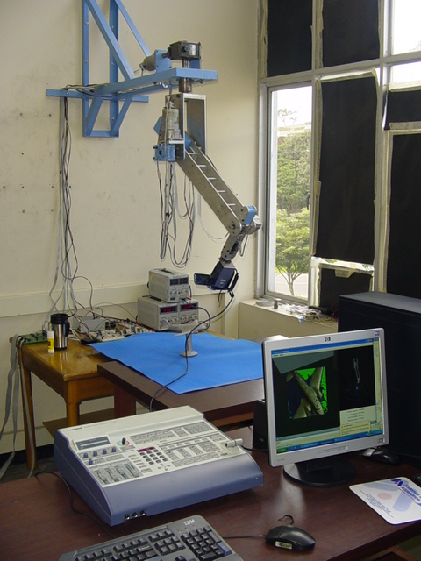  Real Studio :Camera & Robotic Support | video-Mixer  unit  power  and  drivers  S/DV video  line  Serial  Control  Line  3 CPU Cluster: Live Video Stream & J3D Control | 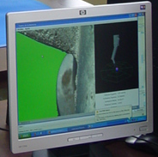  Virtual Studio Interface: Chroma-key image,  Live video display embedded in X3D /J3D environment  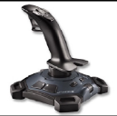 Control Joystick
Figure 1: Virtual studio scheme.

On the other hand, the development of this project has involved an interdisciplinary work from mechanical, electric, electronic and computer design until the virtual studio live implementation that were a high challenge at the beginning of this activity.
2. The Virtual Studio Implementation

2.1. Real Robot Design and Camera Motion Control
A four bar robot was developed to support the Sony DSR PDX- 10 handycam used in virtual studio experimentation. Design features include:

- Slow & soft motion navigation for seamless and continuous object video viewing.
- 360 ° observation field surrounding the upper side of the object’s hemisphere.
- Unrestricted approach of the camera to the object allowing the use of a macro lens if desired.
- The robot components are to be easily transported and assembled in different museum locations (collections) .

Figure 2: Real and Virtual Studio experimentation: Prototype robot support and camera. Java 3D embedding of live video DV video stream 780 x 540p and chroma-keying with green background extraction in the 3d implementation.

The mechanical design was developed with the use of solid edge CAD software and was calculated in the static condition of maximum torque for each joint.

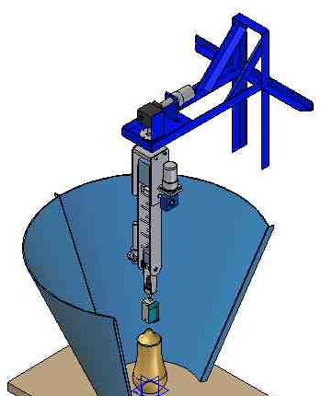 | Body Nº 0 Fixed Structure  Body Nº 1 (shoulder). Fixed position in x, y and z, with vertical rotation.  Principal joint: rotational joint around the Vertical axis.  Body Nº 2: arm  Second joint simple pendulum joint around an horizontal axis fixed in body Nº 1  Body Nº 3 forearm  Third joint revolute joint around an horizontal axis fixed in body Nº 3  Body Nº 4 doll  Fourth join relative rotation of the camera support
Figure 3: Bodies of the camera position control robot.
Unigraphics CAM software was used to manufacture some components, because the fixations and machines use of conventional lathe and conventional universal mill were used for pre machining and to reduce cost in the CNC machines. The use of CAM tools were applied in a Vertical Machining Center Leadwell V20 at the campus for a lower construction cost.

For the movement and control implementation, the selected elements were:

- Principal joint: Driven by: motor 24V DC with planetary reducer and encoder of 100 CPT. ω=140 rpm. Use a worm gear 24:1 ω=5.8 rpm. Auto block.
- Second joint: Driven by motor 24V with planetary reducer and encoder of 100 CPT. ω=140 rpm. Use a worm gear 30:1 ω=4.6 rpm. Auto block.
- Third joint: Driven by: 24V DC Maxon Amax 32 with encoder of 500 CPT for A max 32 T=4.5N-m, ω=8400 rpm. Power=20 Watt. Planetary reducer: GP32A ω=106 rpm
- Fourth joint: Driven by: motor 24V DC Maxon Amax 26 - 11W with encoder of 500 CPT for Amax 26 T=26.9mN-m, ω=8400 rpm. Power= 11 Watt. Planetary reducer: GP32K ω=35,6 rpm

The robot motion control is made with a central programmed unit that work mainly to coordinate the movement of each articulated robot joint composed of a DC servomotor to provide an entire movement involving the museum collection piece exploration. (Control unit: eZdsp F2808 were used).
There are three modules: Trajectory generation: the algorithm generates the reference signals for position, velocity and acceleration to each motion axis. Motor control: conventional PD control algorithms and some other methods are implemented for motion control. Communications: RS232 serial interface to provide two-way communication and synchronization between virtual and real worlds.
Trajectory Generator: the camera motion robot implementation of linear Control algorithms includes a basic double reference system structure, since a very soft and continuous movement is a basic requirement of real camera video visualization. A signal trajectory generator provides the command signal required to that end.
Each of the robot’s joints or body controller should fit the systems basic criteria (critical minimum), errors in stationary position and perturbation. A trajectory is a position, velocity and acceleration time dependent function. The objective is to provide an optimum between an initial (θ₀) and final (θ_{f}) positioning point.
The control loop command signal is generated from the position, velocity and acceleration profiles, which need to be defined to perform a soft and continuous movement. This movement is related to a continuous function with at less first and second order continuous derivatives, or the same, the movement needs to have a continuous acceleration function as shown in figure 4. The trajectory generator parameters are entries such as initial position, final position, and maximum velocity.
Referencing signals for each control loop command are generated by a predefined set, which is fit to produce constant seamless motion paths by each of the mechanical robot’s four component bodies.
The controller configuration is shown in figure 5. It has two reference signals inputs (θref, ωref) and the action is added to produce the total control signal as the conventional PD controller. The position error has a good performance and the overshoot could be easily found fixing the controllers constants.

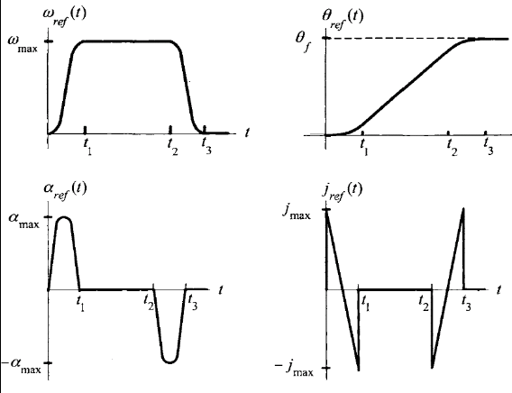
Figure 4: Motion Trayectories Studied ω speed, θ position, α acceleration y j jerk

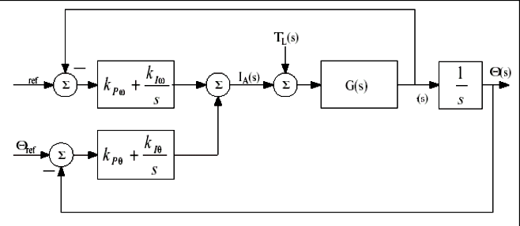
Figure 5: Double reference structure

2.2. The Java 3D Virtual Environment:
Simulation of the real camera motion and its live video 2D surface embedded input within the 3D scene graph consists of a sole Branch Group in which all graphic and control scene elements are included.
The graphic elements are:
- The grid: helps define the virtual environment setting. It contains a simulation of the real exhibit’s position, size and scale that is to be visualized by the user. It also includes some saved WRL/ X3D objects to be imported into the implementation.
- The 2D surface: is synchronized with the real camera position. The live video output of the real camera is streamed as a 2D RGB texture. The 2D surface includes a chroma-key extraction of the exhibit object.
- The virtual model of the robot camera support: includes mechanical virtual capabilities synchronized with the real camera support robot mechanics and dimensions. The user sets an arbitrary viewpoint of the virtual camera thus synchronizing the real camera viewpoint on the exhibit object at the real studio.

The virtual camera support construction involves the constructor’s indexed geometry array works with point values arrays set by a matrix. Thus, simulation and processing of the XYZ coordinate information for each body of the real robot are reduced without having to change the object coordinates in the virtual environment. The class Podio calculates the camera position and the orientation vectors to define the virtual camera viewpoint in the application and feeds back the real model’s motion. The virtual robot model also contains the robot’s real dimensions as non-variable values, which helps with the operation of the virtual model capabilities and synchronization with the real robot.

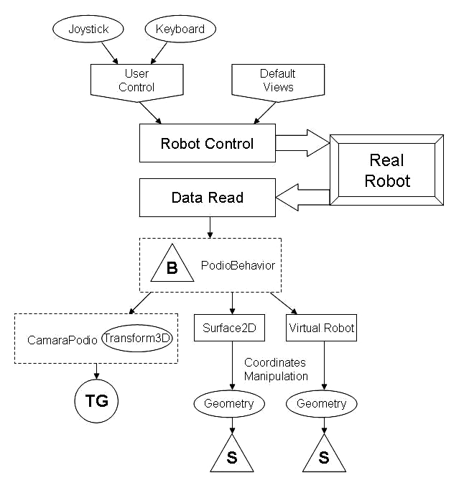

Figure 6: Control Viewing Interface. Java 3D Scene tree components

2.1.1. Behavior of scene control and environment interaction: User interaction with the environment requires real time scene tree modifications, once it’s compiled. Thus, the implemented application includes an extra class PodioBehavior referencing objects of the scene tree defined as the robot camera support simulation. The coordinate modifications are set at the time of execution. The TransformGroup object is also referenced in this class. Data calculations in the object Podio set synchronization of the virtual camera with the user navigation commands. In this class, predefined viewpoints synchronized with the real robot camera’s support mechanical capabilities and field of operation are also implemented. These assist the user’s real camera motion and navigation upon the real exhibit object.

2.1.1. The JAVA 3D GUI. The interface includes both large and small viewpoint display windows and a data chart with the 3D World information. Displays of the simulated robot field operation and the virtual camera viewpoint are synchronized to aid the user with joystick navigation and control. The navigation simulation also includes grid graphic tools for the manipulation of the real robot model. A special feature includes automatic camera navigation from five predefined virtual viewpoints. However, the interface was designed to allow for arbitrary viewpoint navigation. The virtual robot model includes four navigation keys set in the keyboard or in the joystick corresponding to the real model navigation four motion angles and values and an automatic viewpoint indicator (X, Y, Z).

2.1.3. Media stream with JMF and 3D Canvas Embedding. DV 780 x 540p resolution video outputs is used in the video stream implementation. Source Video is transformed into a RGB Canvas3D. A video encoding card is used for this function in order to reduce CPU processing in real time.

This component opens the location of the 3D environment in the system Control Panel of Video stream. Control is carried out by: set Control Panel Component(), of the class Processor. Source video is chroma-keyed with a video-mixer to help reduce processing in the final composition. Object extraction within the 3D environment is completed with software.

3. Hardware & Software
Processing: 3 CPU Cluster Processing Unit. Central node: IBM Intellistation Z pro : Xeon 3.06 ghz(2) Processor, 1 gb –8gb Ram; HP ABM XW4100 Intel Xeon 2.4 ghz; Athlon 1.8 GHZ processor. Video: Handycam Sony DSR PDX –10,

Video-mixer Data Video SE 800 DV, Video Encoder Card Digital Rapids DSR 500 MPEG. Software: API J3D 131, Java SDK 1.4.2, API JMF 2.1.1e, 3D API Cyber VRML 97. Drivers: Control unit eZdsp F2808

4. Results and future Work
Work in the project’s virtual studio tools has been focused on the design, development, and synchronization of the different hardware and software tools to build immersion perception in a virtual studio environment. Development of 3D content includes virtual settings in X3D and WRL and DV live video source viewing. The virtual studio prototype developed is a tool for augmented reality visualization within museum locations. Remote visualization and collaborative environments are included in the next step of the research project: a collaborative ‘Theatre of Memory’: a museum visualization tool for “on demand” collections, gallery settings and object viewing.

5. Conclusion
Immersive 3D Virtual Studio environments implementation as an augmented reality tool in Museum Collections for in site or remote visualization demand high profile hardware and software tools for a very high quality visualization experience. But if a compact viewing tool is solved, an augmented reality tool in museum collections –in site or remote- may help transform the museum experience. Especially in many Museum collections-art exhibitions excluded - i.e. the decorative arts collections - which include many ‘unspectacular’ exhibits, which are also difficult to display because of the variety and extension of the collections items. Such a compact viewing tool may be installed in the museum vaults and basements, where hundreds/ thousands of exhibits are preserved shelved and very rarely actually displayed to the public. The exhibits would be viewed by demand, like in some libraries where the books are handed to the reader/ researchers on request. In-site or remote real image based object viewing may thus open such museum collections to a larger public and facilitate specialized studying.

The development of this project has involved an interdisciplinary work from mechanical, electric, electronic and computer design until the virtual studio live implementation that were a high challenge at the beginning of this activity, the boundaries of the study are open to work on trajectory generation with different techniques, optimization of the mechanical design, another types of robots, remote control and visualization, software limitations of the work space and predefined work space depending of the piece to visualize. This work can be used for supervisory techniques in CAD/CAM and factories of the future too.

Acknowledgements
This research is part of the “Virtual Worlds Memory Theatre” project, for these reason, authors express grateful thanks to people in the Machine Tools Laboratory at Department of Mechanical and Mechatronics Engineering (Jose Luis Pineda, Alberto Ariza and Edgardo Herrera), project assistants (William Santamaria, Oscar Daniel Sanchez and Irene Lema) and to those that worked for this activity (Ricardo Ramirez, Richard Boyaca and Francisco Almonacid.)

References
[1] B. Uribe et Alt, “A Theatre of Memory in Virtual Worlds” 2 International Conference Virtual Worlds, Springer, 2000.
[2] B, Johnson, “Beyond On-line Collections: Putting Objects to work”, Museums and the Web 2004 International Conference, Archives & Museums Informatics, www.archimuse.com.
[3] T, Cinotti , et alt, “Evaluating context –Aware Mobile Applications in Museums: Experience from the MUSE Project, ICHIM 03
[4] W, Thomas, et Alt, “Actual/Virtual Visits: what are the Links?”, Museums and the Web 2005
[5] Park e Inoue , “Real Image Based Virtual Studio”, 1 International Conference Virtual Worlds, Springer, 1998 .
[6] T. Kanade et Alt , “Digitizing a varying 3D Event as is and in Real time; in “ Mixed Reality: Merging Real and Virtual Worlds”, Springer, 1999.
[7] W.P Cockshot, et Alt, “Interactive 3D Studio for TV, The Michelangelo Project, University of Glasgow ,2000; Park, S W et Alt; “Real Time Camera Calibration for Virtual Studio”, Academic Press , 2000
[8] T ,Fukuya, et Alt, “An Effective Interaction Tool for performance in the Virtual Studio”, Studio Systems, 2003.
[9] S ,Rusinkeiewicz, et Alt, “Real Time 3D Model Acquisition” Proceedings of ACM Siggraph 2002.
[10] Kelly, “ Control de Movimientos de Robots Manipuladores”, Prentice Hall 2003.
[11] R Craig, J, “ Introduction to Robotics Mechanics and Control”, Addison Wesly Longman, 1989

